PRINCE ANYETEI LARSEY
ASTA 607_COMPUTATIONAL STATISTICS
INDEX NUMBER: 22424476

QUESTION 1
- Describe the data
R Code
?crabs
# Describe the package

Results:
The crabs data frame has 200 rows and 8 columns, describing 5 morphological measurements on 50 crabs each of two colour forms and both sexes, of the species Leptograpsus variegatus collected at Fremantle, W. Australia.

- Load the dataset and display its structures
R Code
#Load the dataset and display its structures
data(crabs)
str(crabs)

Results
str(crabs)
'data.frame': 200 obs. of 8 variables:
$ sp : Factor w/ 2 levels "B","O": 1 1 1 1 1 1 1 1 1 1 ...
$ sex : Factor w/ 2 levels "F","M": 2 2 2 2 2 2 2 2 2 2 ...
$ index: int 1 2 3 4 5 6 7 8 9 10 ...
$ FL : num 8.1 8.8 9.2 9.6 9.8 10.8 11.1 11.6 11.8 11.8 ...
$ RW : num 6.7 7.7 7.8 7.9 8 9 9.9 9.1 9.6 10.5 ...
$ CL : num 16.1 18.1 19 20.1 20.3 23 23.8 24.5 24.2 25.2 ...
$ CW : num 19 20.8 22.4 23.1 23 26.5 27.1 28.4 27.8 29.3 ...
$ BD : num 7 7.4 7.7 8.2 8.2 9.8 9.8 10.4 9.7 10.3 ...

- Produce Frequency for species and sex
R Code
# Create the frequency table for species and sex
frequency_table <- table(crabs$sp, crabs$sex)

Table 1: Frequency for Species and Sex
Species/ Sex | Female | Male
B | 50 | 50
O | 50 | 50
- Bar Chart for Group composition
R Code
crabs_table <- table(crabs$sex, crabs$sp)

# Construct a grouped bar chart
barplot(crabs_table,
legend = TRUE,
col = c("skyblue", "pink"),
main = "Frequency of Crabs by Species and Sex",
xlab = "Species (B = Blue, O = Orange)",
ylab = "Count")

Results
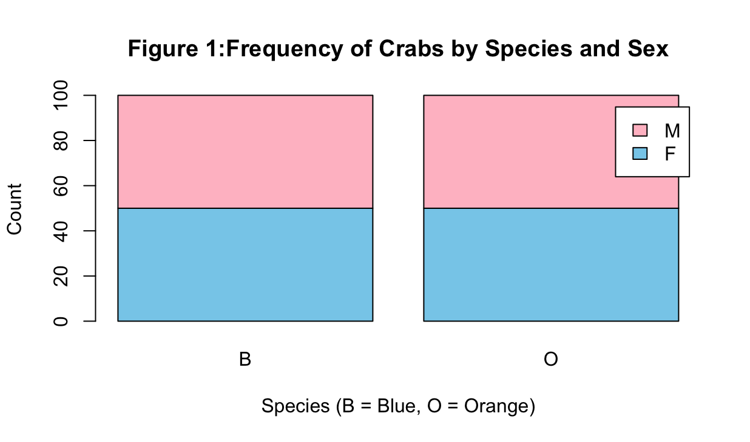

- Figure 1 shows the barplot of Crabs by Species and Sex composition and indicates that there are 50 crabs for each of species.

Question 2

- R Code
# Construct the side-by-side boxplot
# Create an interaction factor for Species (sp) and Sex (sex)
# This defines the four groups: Blue-Female, Blue-Male, Orange-Female, Orange-Male
group <- interaction(crabs$sp, crabs$sex)

Generate the boxplot
boxplot(BD ~ group,
data = crabs,
main = "Body Depth (BD) by Species and Sex",
xlab = "Species (B/O) and Sex (F/M)",
ylab = "Body Depth (mm)",
las = 1) # las=1 rotates axis labels for readability

Results

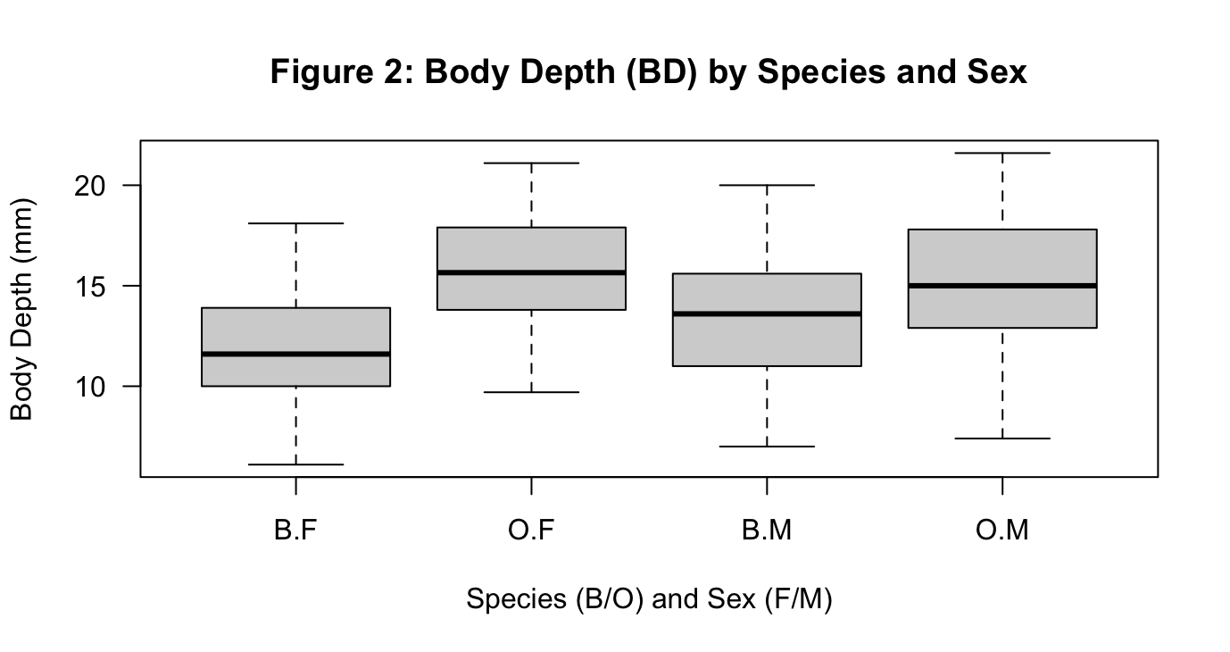

- Identify the outliers and compare

Interquartile Range
Blue Female (B.F): No significant outliers are visible in the standard crab BD data. Blue Male (B.M): No significant outliers. Orange Female (O.F): No significant outliers. Orange Male (O.M): No significant outliers.

Comparison of Central Tendency (Median)

The median (the solid line inside each box) represents the central tendency. Species Comparison: Orange crabs (O) generally show a higher central tendency for body depth compared with Blue crabs (B). Sex Comparison: Within each species, males (M) typically have a slightly higher median body depth than females (F), with the difference being more pronounced in the Orange species.
Variability (IQR) is relatively consistent across all four groups, meaning the middle 50% of the data spread is similar for blue/orange and male/female crabs. Range: The Orange Male group often exhibits the largest overall range in body depth, suggesting it is the most morphologically diverse group for this specific measurement.

Question 3
- Histogram of Carapace length
R Code
# Produce histograms of CL for each species using ggplot2 and facet_wrap
ggplot(crabs, aes(x = CL)) +
geom_histogram(binwidth = 1, color = "white", fill = "skyblue") +
facet_wrap(~ sp) +
labs(title = "Histogram of Carapace Length by Species",
x = "Carapace Length (mm)",
y = "Frequency") +
theme_minimal()

Results
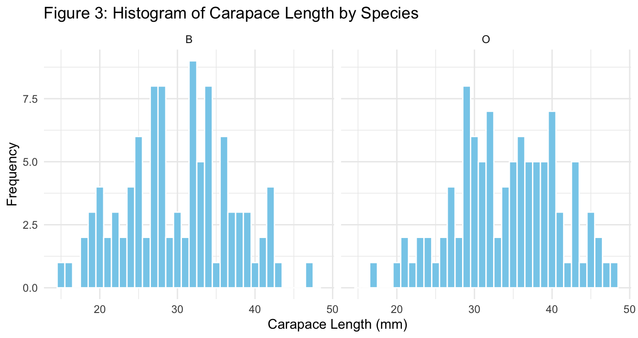

- Compare the shapes, skewness and modality

Unimodal Distribution: Both species exhibit a unimodal distribution (one clear peak). Each species has 100 observations (50 males and 50 females), with sizes ranging continuously from roughly 15 mm to 50 mm.

Uniform Spread: Although the distributions are unimodal, they appear relatively flat or "plateau-like" across the middle range. This occurs because the dataset was deliberately sampled to include 50 specimens of each sex for each species across a broad range of sizes, rather than being a random sample from the wild, which would more typically produce a bell-shaped curve.

Near Symmetry: Both distributions are generally symmetrical, showing no strong positive or negative skew.

Orange Species: Often appears slightly more balanced or centralized around the mean (approximately 30–35 mm).

Blue Species: May show a very slight positive (right) skew due to a few larger individuals that extend the upper tail toward 50 mm, although this effect is subtle.

Question 4
- The mean
R Code
?aggregate
# Compute the mean of FL, RW, CW, and BD grouped by species and sex

mean_measurements_base <- aggregate(cbind(FL, RW, CW, BD) ~ sp + sex, data = crabs, FUN = mean)

# Print the result
print(mean_measurements_base)

Results
print(mean_measurements_base)

sp sex FL RW CW BD
1 B F 13.270 12.138 32.624 11.816
2 O F 17.594 14.836 39.036 15.632
3 B M 14.842 11.718 36.810 13.350
4 O M 16.626 12.262 37.188 15.324

- The grouped bar chart to display

- Identify the measurement
Sexual Dimorphism in Rear Width (RW): Females consistently show a larger Rear Width relative to their size compared to males. This is the most distinct morphological difference between the sexes, as the wider abdomen is an evolutionary adaptation for carrying eggs.
Species Size Variation: The Orange (O) species generally exhibits larger mean values across all five morphological measurements (FL, RW, CL, CW, BD) than the Blue (B) species, indicating it is the larger of the two types.
Strong Linear Correlation: There is a high degree of allometric consistency; as crabs increase in length (CL), they show a proportional increase in width (CW) and depth (BD). This suggests that while species and sex influence size, the fundamental body shape remains relatively uniform across the genus.

Question 5
- Scatter Plot matrix
R Code
# These are columns 4 through 8 in the dataset
measurement_data <- crabs[, 4:8]

# Generate the scatter matrix (pairs plot)
pairs(measurement_data)

Results

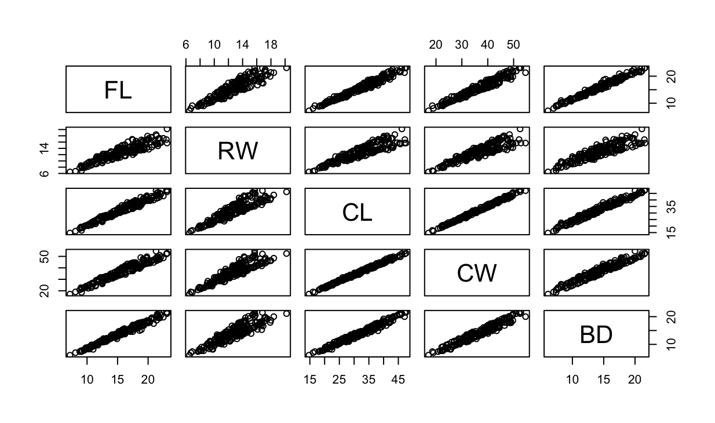

- The relationship between all five variables is extremely strong. The nature of the relationship is positively linear and multicollinearity.

Question 6

The text reports an exploratory data analysis of the `crabs` dataset in R, which contains 200 observations of Australian crabs with 5 morphological measurements, two species (Blue, Orange), and both sexes.
The dataset structure is described: 200 rows, 8 variables (species, sex, index, and 5 measurements). A frequency table shows a perfectly balanced design: 50 females and 50 males in each species (Blue, Orange). A grouped bar chart confirms that each species–sex group has 50 crabs. Side‑by‑side boxplots of body depth (BD) by species–sex groups was created using an interaction factor. No substantial outliers are noted for any group. Orange crabs generally have higher median body depth than Blue crabs. Within each species, males tend to have slightly higher median BD than females. Variability (IQR) is similar across groups, with Orange males showing the largest overall range.
Both species show roughly unimodal, near‑symmetric distributions, with sizes around 15–50 mm.
The distributions look relatively flat in the middle range because the sample was deliberately spread across sizes, not randomly sampled. Blue crabs may show a very slight right skew; orange crabs appear more centrally concentrated around 30–35 mm.
Orange crabs (both sexes) generally have higher mean measurements, and within species, male usually have slightly higher means than females. A grouped bar chart (described but not shown) is intended to visualize these mean differences.
A scatterplot matrix of the five measurement variables (columns 4–8) was created. All five measurements show very strong, positive linear relationships with each other, indicating strong multicollinearity.

